
Queen

Anne’s

County
County Commissioners:
James J. Moran, At Large
Jack N. Wilson, Jr., District 1
J. Patrick McLaughlin, District 2
Philip L. Dumenil, District 3
Christopher M. Corchiarino, District 4
THE COUNTY COMMISSIONERS OF
QUEEN ANNE’S COUNTY
The Liberty Building
107 North Liberty Street

Centreville, MD 21617

e-mail: QACCommissioners&Administrator@qac.org

County Administrator: Todd R. Mohn, PE
Executive Assistant to County Commissioners: Stephanie L. Jarrell
County Attorney: Patrick Thompson, Esquire

Media Contact
June 30, 2026
Beth Malasky
bmalasky@qac.org

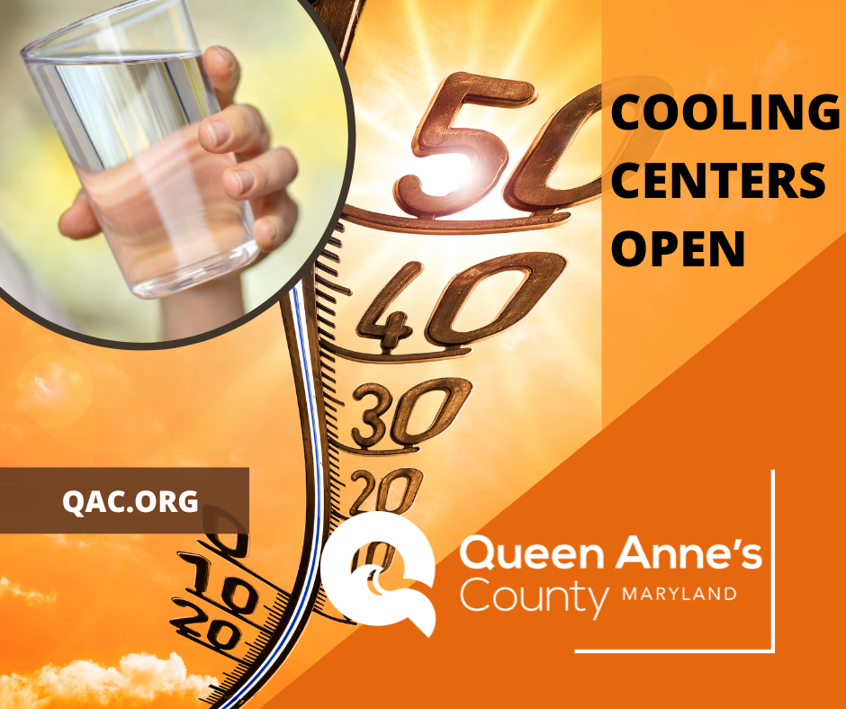

Cooling Centers Open This Week Due to Excessive Heat
Due to Extreme Heat Watches with the Heat Index expected to reach or exceed 105F, Queen Anne’s County Cooling Centers are available for any community members in need of a cool retreat Thursday, July 2 through Sunday, July 5. The Department of Aging & Transportation, Queen Anne’s County Library, and Haven Ministries Jacob Sloan Center will open their facilities to the public.

Locations and Hours
Thursday July 2 – 8:00 AM – 4:00 PM
- Sudlersville Senior Center – 605 Foxxtown Road, Sudlersville, MD
- Grasonville Senior Center – 4802 Main Street, Grasonville, MD
- Kent Island Senior Center – 891 Love Point Road, Stevensville, MD
Thursday July 2 – 9:00 AM – 8:00 PM
- QAC Library – Centreville Branch – 121 Commerce Street, Centreville, MD
- QAC Library – Kent Island Branch – 200 Library Circle, Stevensville, MD
Friday, July 3–Sunday, July 5- 9:00 AM – 5:00 PM
- The Jacob Sloan Center – Haven Ministries – 7401 Main Street, Queenstown, MD
For the latest weather information, visit www.weather.gov/phi.

