**Mobile Visitors Center Trailer for Queen Anne’s County, MD**

**RFP Questions and Answers**

1. Does the county currently have any other Interactive Kiosks deployed?

No

2. If yes, What software system do you use for Content Management?

Wordpress and DropBox

3. Will the county provide artwork renderings for the wrap/branding?

Yes, if needed.

4. Can you provide color codes for carpeting, paint, accessories?

Style guide color codes are listed below.

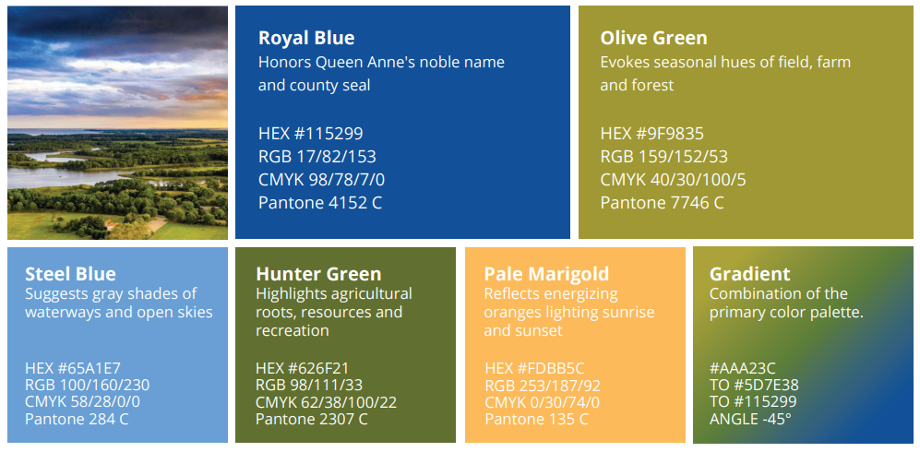

5. Is the County exempt from Sales Tax?

Yes, Queen Anne’s County Economic & Tourism Development is tax exempt.

6. Do you want this trailer built in a steel or an aluminum frame?

Aluminum if cost allows, either material is an option.

7. What kind of interior flooring finish do you want?

Flooring finish would depend on the design of the trailer.

8. How many outlets do you need?

Minimum of 4 – would depend on the design of the trailer.

9. Do you need a generator for this trailer?

Yes, to use when electric isn’t available.

10. Do you have sizes or any more specifics for any of the equipment that you want provided in the trailer?

No – TVs and digital options would be preferable with sizes depending on the rest of the design of the trailer.